# Media Analysis - ChatGPT outperforms copywriters in STEP Conference’s outdoor adverts

## Short Summary

The article highlights how the Step Conference utilizes ChatGPT as an AI tool to boost content creation efficacy within their team, recognizing its dual role in enhancing both process efficiency and maintaining human creativity in tasks such as copywriting.

## Summary

1. ChatGPT has taken over advertising campaigns for the STEP Conference in Dubai, including outdoor advertisements featuring taglines like "Your money needs a side hustle," and "Art on the wall is so last century."  
2. The company plans to continue using ChatGPT as an AI tool across their team for creating, summarizing, and explaining content whenever needed.  
3. Dargham explained that ChatGPT provides efficiency, enabling creative teams to work faster and more efficiently, with the chatbot functioning like an artificial intelligence assistant.  
4. The integration of ChatGPT into the company's workflow has led to a new role for the team - they now view AI as complementary rather than competitive, with human talent finding more productive uses elsewhere.  
5. Despite concerns about job displacement due to automation, experts argue that AI creates jobs faster than it eliminates them. For instance, one report suggests 85 percent of jobs in 2030 have not been invented yet.  
6. Dargham acknowledged the potential for copywriters to be replaced by chatbots but emphasized that human creativity remains extremely valuable and will find more meaningful applications with AI tools.  
7. He foresees a future where ChatGPT and other AI tools complement and potentially replace certain human tasks, while also highlighting opportunities for humans to engage in roles requiring higher cognitive functions.

## Question 1:

How do the media (in our case = the sample we are analyzing) frame the public discussion about ChatGPT? Are there certain **metaphors** that keep cropping up?

1. 'Artificial Intelligence as a Side Hustle' This metaphor is used to illustrate how AI-generated content, such as ad taglines, are seen as an addition or alternative to human creativity. The use of the term 'side hustle' implies that these tools can potentially replace or supplement human work, offering convenience and efficiency without diminishing their value.

## Question 2:

Which role does the Arabic World play in the field of Artificial Intelligence in this article according to the author? Answer with 'Not mentioned' if not applicable.

The Arabic World plays a pivotal role in the field of Artificial Intelligence, showcasing its adoption and integration of advanced technologies like ChatGPT. It is utilizing these tools to streamline content creation processes, making tasks more efficient and creative.

## Question 3:

How helpful is Artificial Intelligence for the Arabic world based on this article?

The article suggests that Artificial Intelligence, particularly ChatGPT, is helpful for the Arabic world by improving marketing processes, generating engaging content, and complementing human creativity. However, it doesn't replace human talent entirely instead, it offers assistance, potentially expanding job opportunities in this field.

## Question 4:

What is the final message of the article that the author wants to convey? Keep your answer short and precise!

The final message conveyed in the article is that ChatGPT and other AI tools are complementary to human creativity, enhancing productivity while preserving the unique value of human ingenuity in fields like copywriting.

## Sentiment

The sentiment is 2

## Entities

Art, STEP, Microsoft, AI, Dargham clari ed, STEP Conference's, Ray Dargham, Dargham, STEP Conference, Arab News, Google, Meta's Open Pretrained Transformer

## Topic Clusters

### Cluster: AI and Technology Impact on Society

ChatGPT, Artificial Intelligence, Societal Effects

### Cluster: Ethical Considerations in AI Development

Privacy Concerns, Bias in Algorithms, Accountability

### Cluster: Arabic Newspapers Coverage of AI and ChatGPT

Local Perspectives, Industry Insights, Regulatory Discussion

## Word Clouds

### Wordcloud of content

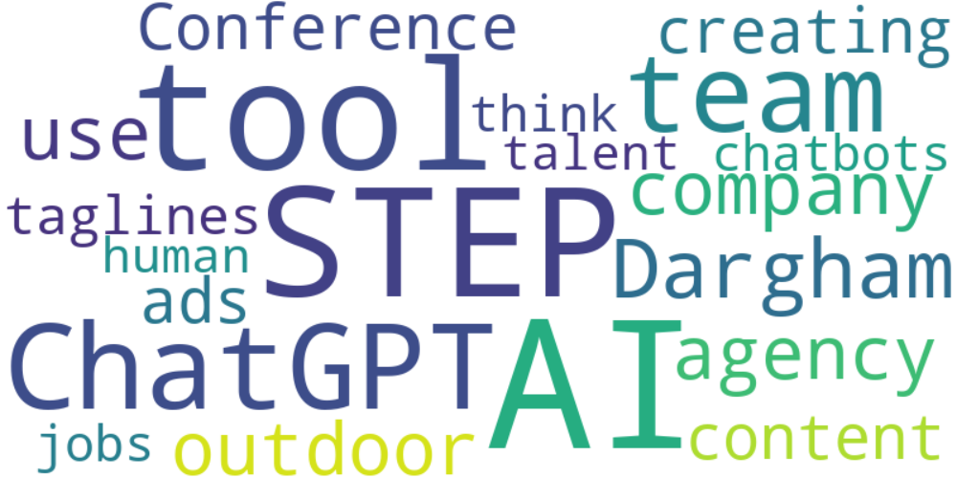

Top 10 words:

- AI: 10

- STEP: 7

- ChatGPT: 6

- like: 6

- team: 5

- Dargham: 5

- outdoor: 4

- company: 4

- use: 4

- agency: 4

### Wordcloud of summary



Top 10 words:

- ChatGPT: 5

- AI: 5

- human: 3